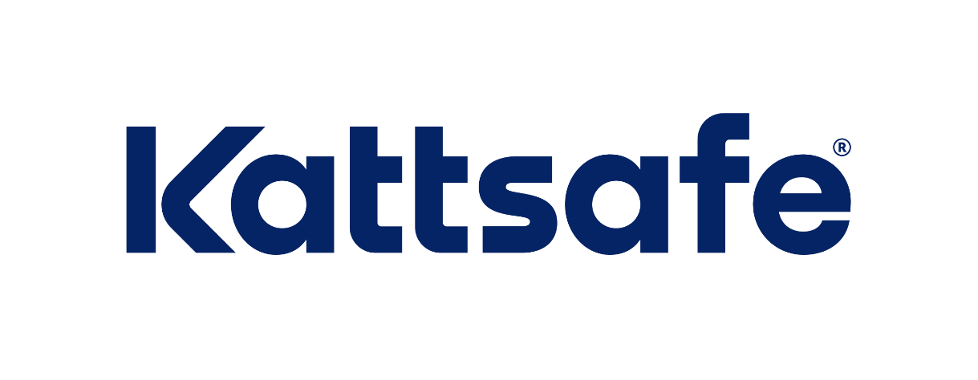
SECTION 077200 (07 7200)
ROOF ACCESSORIES
Copyright 2016 - 2025 ARCAT, Inc. - All rights reserved

- GENERAL
  - SECTION INCLUDES

    - Roof Hatches
            - Personnel Series are metal, single door hatches used by personnel. Tested for wind-uplift, forced entry and air infiltration where basic wind speed reached greater than 70 miles per hour
    - Accessory Products for Roof Hatches
            - Safety Railings for all roof hatches
            - Roof Hatch Hoist and Cargo Net
  - RELATED SECTIONS

    - Section 05500 - Metal Fabrications: Associated metal supports.
  - COORDINATION
    - Coordinate layout and installation of roof accessories with roofing membrane and base flashing and interfacing and adjoining construction to provide a watertight installation.
    - Coordinate dimensions with rough-in information or Shop Drawings of equipment to be supported.
  - SUBMITTALS
    - Shop Drawings: Indicate configuration and dimension of components, adjacent construction, required clearances and tolerances, and other affected Work.
            - Hatch Units: Show types, elevations, thickness of metals, and full-size profiles.
            - Hardware: Show materials, finishes, locations of fasteners, types of fasteners, locations and types of operating hardware, and details of installation.
            - General: Show connections of units and hardware to other Work. Include schedules showing location of each type and size of unit
    - Product Data: Manufacturer’s technical data for each type of hatch assembly, including setting drawings, templates, finish requirements, and details of anchorage devices.
            - Include complete schedule, types, locations, construction details, finishes, latching or locking provisions, and other pertinent data.
  - INFORMATIONAL SUBMITTALS
    - Provide manufacturer's standard warranty.
    - Sustainable Design Submittals:
          - Building Product Disclosure Requirements: To encourage the use of building products that are working to minimize their environmental and health impacts, provide the following information when available:
            - Material Ingredients Documentation demonstrating the chemical inventory of the product
  - CLOSEOUT SUBMITTALS
    - Manufacturer's Installation Instructions and Operation & Maintenance: Indicate installation, operation and maintenance requirements and rough-in dimensions.
  - QUALITY ASSURANCE
    - Regulatory Requirements:
          - Miami-Dade County, FL Approved NOA
            - TAS 201 Impact test
            - TAS 202 Uniform Static Air Pressure
            - TAS 203 Cyclic Wind Pressure Loading
          - OSHA 29 CFR 1910.23 Guarding floor and wall openings and holes
          - OSHA 29 CFR 1919.29 Fall protection systems and falling object protection-criteria and practices.
          - OSHA 29 CFR 1926.502 Fall protection systems criteria
          - International Building Code (IBC) Section 1013.6 Roof Access
          - International Building Code (IBC) Section 1009.11 Means of Egress, Stairways, Stairway to Roof
  - DELIVERY, STORAGE, AND HANDLING
    - Deliver materials to Project site ready use.
    - Exercise proper care in handling of Work so as not to disrupt finished surfaces.
    - Store materials under cover in a dry and clean location off the ground.
  - PROJECT CONDITIONS

    - Field Measurements: Where handrails and railings are indicated to fit to other construction, check actual dimensions of other construction by accurate field measurements before fabrication.
    - Maintain environmental conditions (temperature, humidity, and ventilation) within limits recommended by manufacturer for optimum results. Do not install products under environmental conditions outside manufacturer's recommended limits.
  - WARRANTY
    - Warranty: At project closeout, submit an executed copy of the manufacturer's five year standard limited warranty against manufacturing defect, outlining its terms, conditions, and exclusions from coverage.
- PRODUCTS
  - MANUFACTURERS
    - Acceptable Manufacturer: Kattsafe, which is located at: 5199 E 500 S, Suite 100, Whitestown, IN 46075; Toll Free: 888-637-7872; Phone: 317-769-7710; Fax: 317-229 6451; Email: sales@kattsafe.com; Web: https://www.kattsafe.com.

    - Substitutions: Not permitted.
    - Requests for substitutions will be considered in accordance with provisions of Section 01600.
  - ROOF HATCH
    - Roof Hatches:
          - Type and Size: Personnel, Galvanized Steel or Aluminum, [KH3630, 36 by 30 inches (915 by 760 mm)] [KH3054, 30 by 54 inches (760 by 1370 mm)] [KH3636, 36 by 36 inches (915 by 915 mm)] [KH4848, 48 by 48 inches (1220 by 1220 mm)] [KH3096, 30 by 96 inches (760 by 2440 mm)]

Verify load requirements with authorities having jurisdiction.
Miami-Dade County, FL Product Control Approved for units with Aluminum Curb and Cover (RHUA) and galvanneal steel curb and cover (RHUG) with a maximum size of 16 Sq Ft for a single point latch and 20 Sq Ft for a two-point latch.

            - Performance Requirements
              - Units shall be Miami-Dade County, FL Product Control Approved meeting large and small impact requirements. Miami-Dade County Approved NOA# 21-1201.02 Expiration Date January 27, 2027
              - Hatch shall be reinforced to support live load of 40-lbf/sq. ft. (1.9-kPa) with a maximum deflection of 1/150th of the span with a wind load of plus or minus 140-lbf/sq. ft. (6.70-kPa).
            - Loads
              - Units less or equal to than 60 inches (152 cm) in length: Minimum 40-lbf/sq. ft. (1.9-kPa) external live load with a maximum deflection of 1/150 of the span and 20-lbf/sq. ft. (0.95-kPa) internal uplift load
              - Units greater than 60 inches (152 cm) in length: Minimum 40-lbf/sq. ft. (1.9-kPa) external uplift load with a maximum deflection of 1/150 of the span and 90-lbf/sq. ft. (4.31-kPa) internal uplift load
            - Hatch Material:
              - Cover: [0.07895 inch (1.9 mm) galvanneal steel] [0.0907 inch (2.3 mm) aluminum] [0.0907-inch (1.9-mm-) thick Type 304 stainless steel].
              - Cover Insulation: 1 inch (25 mm) polystyrene
                - Insulation Options: [1 inch (25 mm) polyisocyanurate] [2 inch (50 mm) polyisocyanurate]
Curb height in "Curb: paragraph below may be determined by adding thickness of roof insulation to the minimum base flashing height recommended by roofing membrane manufacturer or established by office practice.
              - Curb: [0.07895 inch (1.9 mm) galvanneal steel] [0.0907 inch (2.3mm) aluminum] with a [single wall] [double wall] [consult manufacturer for additional curb options], curb and integral railing ready EZ tabbed counter flash. Mounting flange continuous around base of frame.
                - Fabricate curbs to minimum height of [12 inches (305 mm)] [<Insert dimension> above roofing surface unless otherwise indicated.
                - Sloping Roofs: Where slope or roof deck exceeds 7:12, fabricate curb with perimeter curb height that is tapered to accommodate roof slope so that top surfaces of perimeter curb are level.
              - Curb Insulation: 1 inch (25 mm) Polyisocyanurate
                - Insulation options: [2 inch (50 mm) polyisocyanurate]

First option in "Finish" subparagraph below applies only to aluminum
            - Finish: [Mill finish] [TGIC Polyester powder coat paint] [Trinar].
Retain "Color" subparagraph below if retaining second option in "Finish" subparagraph above.
            - Color: [Red Oxide] [High Reflectance White] [As indicated by manufacturer's designations] [Match Architect's sample] [As selected by Architect from manufacturer's full range] <Insert color>.
            - Hardware: [Zinc plated steel] [Stainless Steel].
              - Hinge Assembly: Pintle hinge with stainless steel hinge pin.
              - Spring: Gas spring with integrated damper.
              - Hold Open Device: Automatic zinc plated steel hold open arm with red vinyl grip handle.
              - Latch: Zinc plated steel spring-type slam latch with inside and outside operating turn handles and padlock hasp provisions.
              - Pull Handle: Interior pull down handle, powder coated safety yellow.
              - Gasket: Extruded EPDM adhesive back seal, continuous around cover.

  - ROOF HATCH GUARDRAILS
    - Basis of Design: Kattsafe Aluminum Roof Hatch Guardrail System by Kattsafe. A fixed railing system providing permanent fall protection for hatch openings. Available in multiple sizes, and can fit most existing hatches or installed on the Kattsafe Roof Hatch. A clamping system eliminates the need to drill holes into the hatch or roof surface, jeopardizing the roof warranty. Installs in minutes with basic tools.
      - Sizes: Standard roof hatch sizes available in stock. Can be custom made to fit irregular roof hatch sizes.
      - Color: Safety Yellow Standard. Powder Coating Available.
      - OSHA Compliance: 1910.28(b)(3)(i), 1910.28(b)(3)(iv).
      - Warranty: 10 years. Does not include moving parts.
      - Exit Types: Front, front1, front2, left, or right.
      - Roof Hatch Flange Length: ___ inch (___ mm).
      - Roof Hatch Flange Width: ___ inch (___ mm).
      - Self-closing gate.
      - Grabrails.
      - Handrail Tubing: 2 inch (51 mm) round, Aluminum 6106-T6.
        - No. 10 x 5/8 inch (16 mm) Stainless Steel Self tapping screws: Two per post.
        - Handrail end caps.
      - Mid rail Tubing: 1-5/8 inch (41 mm) round Aluminum 6061-T6.
        - No. 12 x 2 inch (51 mm) Stainless Steel Self tapping screws: Two per post.
      - Clamping System Frame: Kattsafe.
- EXECUTION
  - EXAMINATION
    - Verification of Conditions: Examine areas and conditions under which Work is to be performed and identify conditions detrimental to proper or timely completion.
    - Verify that deck, curbs, roof membrane, base flashing, and other items affecting Work of this Section are in place and positioned correctly.
    - Verify tolerances and correct improper condition
    - Identify conditions detrimental to providing proper quality and timely completion of work.
    - Do not proceed with installation until detrimental conditions have been corrected.
  - PREPARATION
    - Clean surfaces thoroughly prior to installation.
    - Prepare surfaces using the methods recommended by the manufacturer for achieving the best result for the substrate under the project conditions.
  - INSTALLATION
    - Install in accordance with manufacturer's instructions, approved submittals and in proper relationship with adjacent construction.
    - Coordinate installation of components of this Section with installation of roof deck, roof structure, roofing membrane, and base flashing.
    - Coordinate installation of sealant and roofing cement with Work of this Section to ensure water tightness.
    - Securely anchor roof accessories in compliance with manufacturer's instructions.
    - Set units plumb, level, and true to line without warp or rack. Separate metal from incompatible metal or corrosive substrates, including wood, by coating concealed surfaces, at locations of contact, with bituminous coating or providing other permanent separation.
    - Flange Seals: Unless otherwise indicated, set flanges of accessory units in a thick bed of roofing cement to form a seal
  - ADJUSTING
    - Adjust movable parts for smooth operation
    - Operational Units: Test-operate units with operable components. Clean and lubricate joints and hardware. Adjust for proper operation.
  - PROTECTION
    - Protect installed products until completion of project.
    - Touch-up, repair or replace damaged products before Substantial Completion.
  - CLEANING
    - Clean exposed surfaces per manufacturer's written instructions. Touch up damaged metal coatings.

END OF SECTION

